DAY 34_Built in Function_Python
Remove Duplicates & Preserve Order
Concepts: set(), list, loop
Problem:
Given a list of student IDs, remove duplicates without changing order. ids = [101, 102, 101, 103, 102, 104]
Expected Output:
[101, 102, 103, 104]
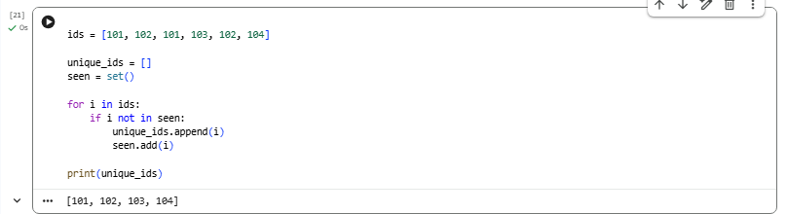
Frequency Counter (Real-time analytics)
Concepts: dict, get(), loop
Problem:
Count how many times each product is sold. products = ["apple", "banana", "apple", "orange", "banana", "apple"]
Expected Output:
{'apple': 3, 'banana': 2, 'orange': 1}
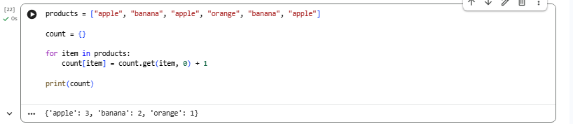

Find Top Scorer Concepts: max(), dict
Problem:
Find the student with highest marks.
marks = {"A": 85, "B": 92, "C": 88}
Expected Output:
B 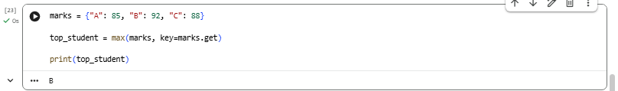
Common Elements in Two Lists
Concepts: set(), intersection()
Problem:
Find common skills between two candidates.
skills1 = ["Python", "SQL", "Excel"] skills2 = ["SQL", "Power BI", "Python"]
Expected Output:
['Python', 'SQL'] 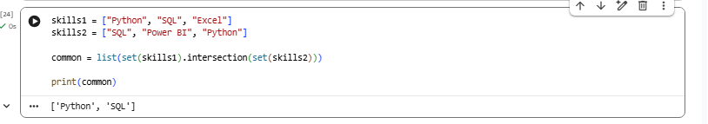
Sort Dictionary by Values Concepts: sorted(), lambda
Problem:
Sort products by price. prices = {"apple": 50, "banana": 20, "orange": 30}
Expected Output:
[('banana', 20), ('orange', 30), ('apple', 50)]
